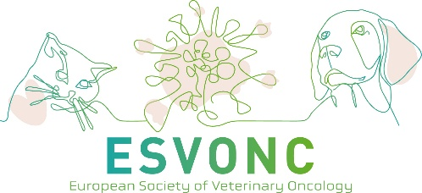

**Application Format**

**for the ESVONC Clinical Research Fund**

The ESVONC Clinical Research Fund invites members of the ESVONC to submit a research application for a maximum amount of €5000. The topic should be on veterinary oncology and clinical oriented, including medical and surgical oncology and radiation therapy. Applications should be sent in by e-mail before April 1, 2026, to [SECRETARY@ESVONC.COM](mailto:SECRETARY@ESVONC.COM) and will then be forwarded to members of the ESVONC Clinical Research Fund Committee for evaluation. During the ESVONC Annual Congress the winners of the grants will be made known.

Each ESVONC member may submit one application (one electronic copy), which should be typed in Arial font 11 point and double-spaced, numbering consecutive pages from the Cover Page (page 1).

Applications should be succinct and comprise (sub-section headings italicized):

1. A Cover Page with research title, investigators, and affiliations

2. An Abstract (not more than 300 words)

3. An Introduction and Scientific Background (not more than 400 words)

4. An account of the Contribution of the Project to Veterinary Oncology in Europe (not more than 400 words)

5. A detailed description of the Research Plan, including a sub-section entitled Hypothesis and SMART Objectives (not more than 1000 words), justification of sample size.

6. Ethical approval (if not yet obtained, then at the latest May 15 proof of it should be sent)

7. References (maximum of 40)

8. Budget details, including a sub-section entitled Justification (not more than 400 words)

9. Timeline (not more than 300 words)

10. Curricula Vitae of the principal and all co-investigators (not more than two pages per investigator)

*Please note that applications not adhering to these formatting guidelines will be rejected without further consideration. Please also note that we will NOT review projects under consideration by alternative funding bodies. If parts of the projects have been financed by other funding bodies, proof of this should be given. The grant will not cover any salary of researcher/students, nor travel or publication costs. A maximum of 10% overhead costs is allowed.*