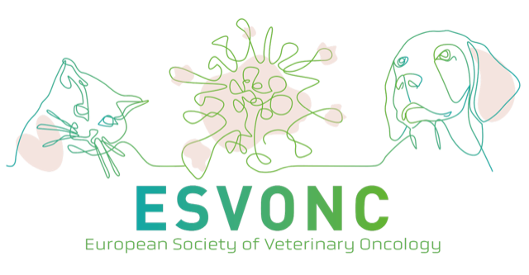

Further Guidance for submissions to the ESVONC 2026 Nurse and Technician Presentations
Submissions are now open for unique and interesting vet nurse case reports, to be presented at ESVONC Congress 2026 in Dublin on 22nd - 23rd May. Below is further guidance to assist with structuring presentation proposal submissions:

CASE REPORTS: The case report can be in any area of small animal oncology nursing, from nurse clinics to critical care. The submission needs to include a short synopsis of the case, using the following outline:
- Introduction – to include the unique or interesting aspect
- Synopsis of the case – signalment, initial assessment, physical findings, intervention, patient care and recovery, final outcome
- Discussion – focus on the specific nursing care and interventions
- Conclusion – the key nursing points that were learnt from the case, specialised skills and any specialized monitoring equipment used during the case
All case report presentations will be limited to fifteen minutes, inclusive of time for questions.

CARE TIPS: The care tips presentations can be in any area of small animal oncology nursing that demonstrates a method of practice (whether standardised or novel) which you believe is integral to enhancing patient care, safety, or efficiency. The submission needs to include a short synopsis of the technique, using the following outline:
- Introduction – to include the unique or interesting aspect of the method, and brief reasoning why the idea was originally postulated.
- Methodology – explanation in a step-by-step approach to the technique or skill
- Discussion – focus on the specific nursing involvement in the described approach and the noted benefits of using the described technique
- Conclusion – the potential impact on patient care and/or clinical practice if more colleagues utilised this method.
All care tip presentation will be limited to fifteen minutes, inclusive of time for questions.

Nurse/Technician case reports and care tips presentations are encouraged for submission by veterinary nurses who have not had the opportunity to lecture before, although it is not limited to these individuals.
DEADLINES
- Case reports and Care Tip Presentations must be submitted by 13th April 2026
- Notification of acceptance and invitations will be sent by 20th April 2026
- Speaker Biography and synopsis must be submitted by 30th April 2026

REVIEWING PROCESS
Due to limited availability, all presentation submissions will be assessed by a panel of oncology specialist nurses and clinicians, with successful candidates chosen to present at ESVONC Congress.
The Nurse/Technician case reports and care tips will be delivered in-person, on 23rd May 2026 and will be evaluated by members of scientific committee attending the nurse/technician stream; an award will be given for the overall best nursing presentation.
Please submit your case reports to the ESVONC Secretary, emailing secretary@esvonc.com with ‘Case report or Care Tip’ as the subject line. To find out more about the scientific program for ESVONC Congress 2026, visit: https://www.esvonc.com/congress

Nicola Read RVN, ESVONC Congress Nurse Liaison Officer said:
“Every day, oncology nurses and technicians make a meaningful difference through compassionate care, clinical expertise, and innovative practice. I am absolutely delighted that ESVONC’s Annual Congress continues to feature a session for colleagues to share experiences, reflect on challenges and successes, and most importantly learn from one another. We welcome case reports that capture real-world nursing practice, unique patient journeys, creative solutions, or lessons that have shaped your care. No previous presenting experience is necessary – we want to hear from nurses and technicians proud of sharing their work with our community.

